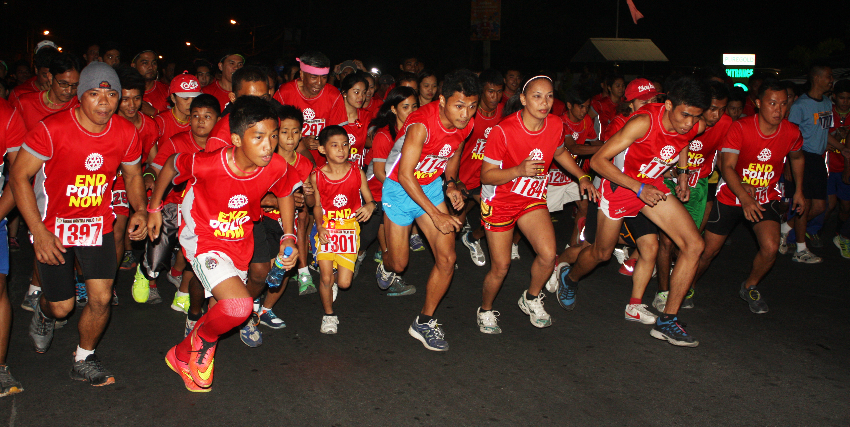

#Play4More

I’m dedicating my soccer match/cricket match/music concert to END POLIO because every kid deserves a chance to play and win! #play4more
Dear _________________,
I am on the xxxxxxxxxx team. Insert reason for participating in sport/event. Ex: I play to stay healthy. I play to challenge myself. I also want these challenges to mean something.
I’m dedicating my game to END POLIO. Polio still affects children all over the world. Polio has no cure, but it is preventable with a vaccine. With your help, we can make polio the second human disease to ever be eradicated. Help me make history and give every child a chance to play, to win, to be part of a team and challenge themselves.
Everyone wants to win, but it’s not why we play. Use your energy and inspiration to change the world. Dedicate your ride, match, or concert today. This time, I want to #PLAY4MORE. I play to #endpolio.
You can sponsor my event. Donate online at my personal Rotary fundraising page Insert link to personal ideas.rotary.org fundraising page. (Please make checks payable to The Rotary Foundation and put #endpolio in the memo.) All donations made to Rotary for polio eradication will be tripled by the Bill and Melinda Gates Foundation.
Thank you!
NAME

